1.SignendIn with correct username and password:

2. signedIn failed with incorrect password:

3. SIgnedUp with username, user_pass and email in JSON format:

4. Home Page when no user is logged in.

5. Logging in with a valid username and password

6. Settings tab to filter out desired type of news. User can choose one or multiple types of news as desired and save it.

7.Categories will be updated successfully as per the user’s choices and updation message will be displayed.

8. Clicking in a particular article will redirect the user to the particular website the new has been posted. i.e foxbusiness.com or cnn.com etc

9. Clicking the logout button will log out the user and will redirect to the signin page.

10. Clicking the Remember me box will save the username for future reference.

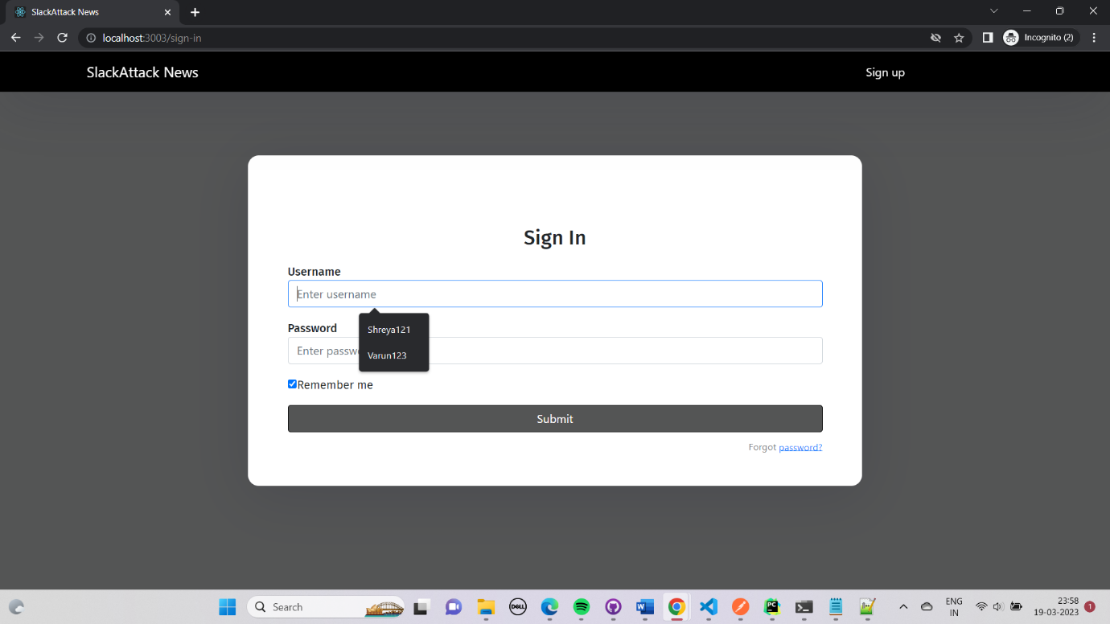

11. GET request in POSTMAN for “News” with valid credentials.

12. GET request in POSTMAN for “News” for a particular user with invalid username.

13. GET request in POSTMAN for “Categories” for a particular user with valid credentials.

14. GET request in POSTMAN for “Categories” for a particular user with invalid username.

15. UI testing for Login module.

15. UI testing for Signup module.

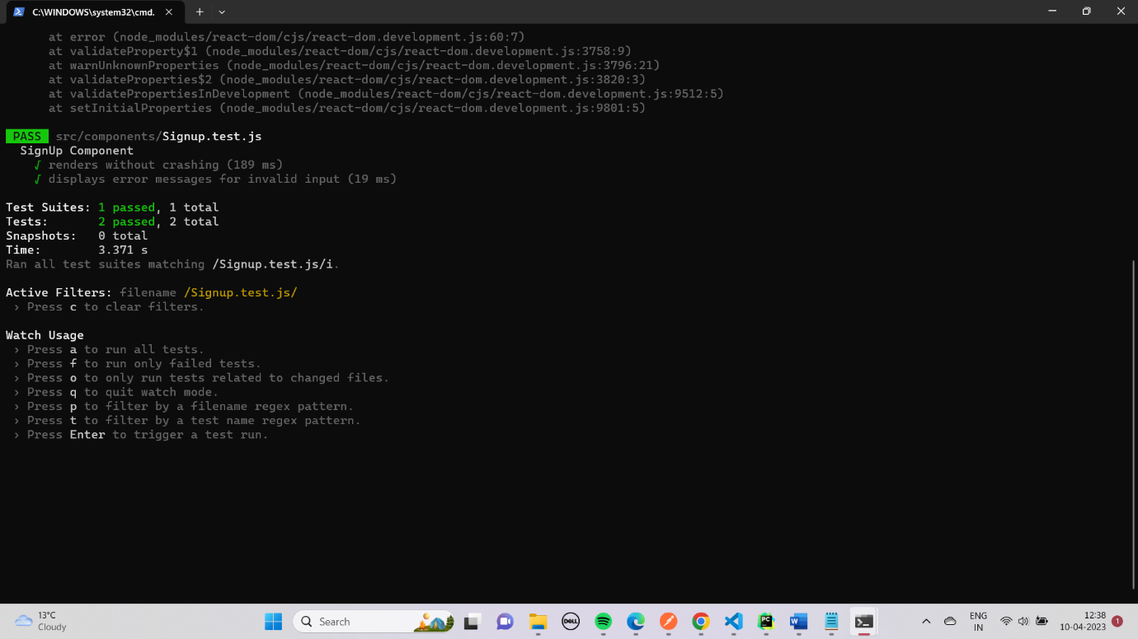

16. Homepage UI without any user login.

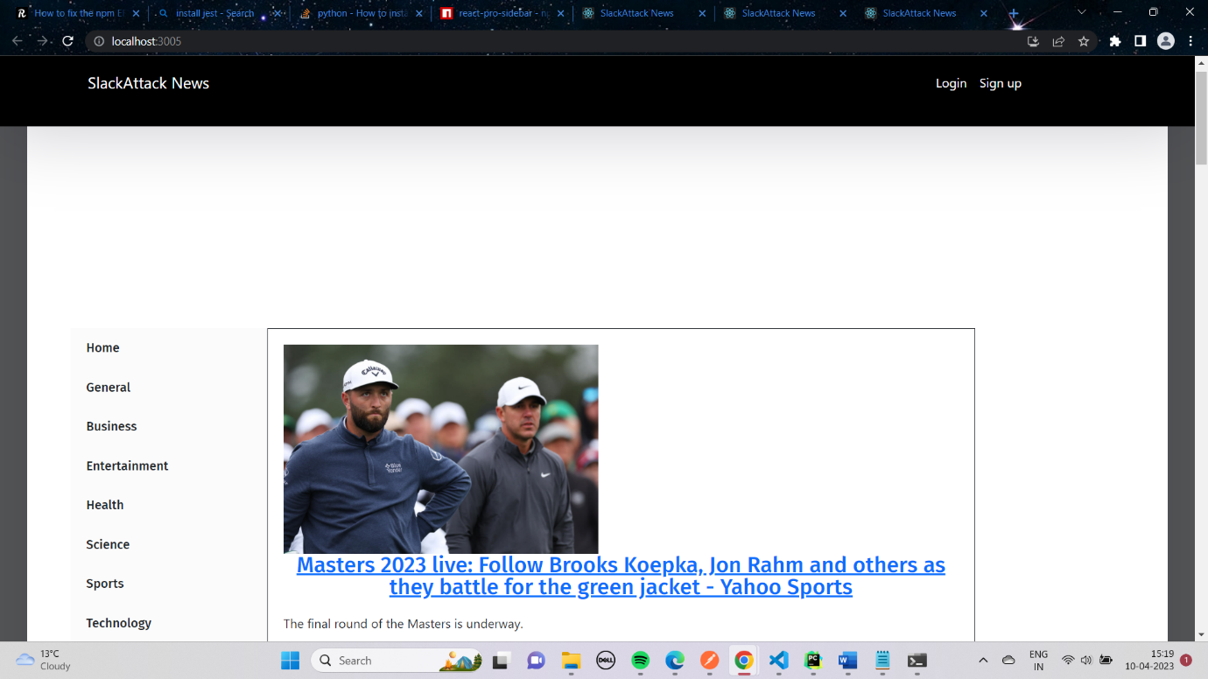

17. Pagination in UI

18. Implementation of search bar in the UI.

18.1. Searching with the word “celiac”.

18.2. Search results for “celiac”.

19. Test results for sign_in unit test with valid credentials.

20. Test results for sign_in unit test with invalid credentials.

21. Testing results for Pagination for UI.